Coursework Logbook

29/11/2023
Revised difference between C, C++, avr C and avr C++, revised about GNU C Compiler, GCC, and difference with avr-gcc. Installed relevant command line tools (avr-gcc, gnuwin for make, and avrdude) through https://scoop.sh/.

Refreshed basic C and avr C commands, refreshed about Il Matto.

30/11/2023
Restudied C through C wikibooks https://en.wikibooks.org/wiki/C_Programming.
https://en.wikibooks.org/wiki/Embedded_Systems/C_Programming.
Used CoPilot and setup VSCode settings properly for proper autocomplete and library peek (GCC).
Created example LED blink test on avr-test in Coding folder in OneDrive together with makefile (make all, clean and flash using avrdude).
Tried following https://izzudinhafizprojects.wordpress.com/2021/04/05/setting-up-visual-studio-code-vscode-for-avr-programming-not-arduino/ and copilot instruction to be able setup c/c++ intellisense properly but to no avail, no error squiggles but still cant CTRL+CLICK on library to peek inside, and no autocomplete functions that haven’t been written yet?

Application Layer

1/12/2023
Did some testing with UART and LED, works like a charm, thanks copilot. Refer https://github.com/Muhammad-Hazimi-Yusri/AVR-C-Examples
Hell yea using git branching is so good, I branched to application branch to focus on it. Will have 2 more branch, transport and application transport.
Makefile is still a bit annoying, but copilot helps a lot, also if copy pasting Makefile code from copilot window to vscode, make sure to replace tab with real tab as it gives separator error.
Linking library in compiler flags, adding them properly as source:
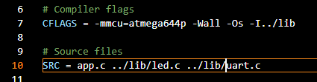
And build .o file for each .c file for linking? 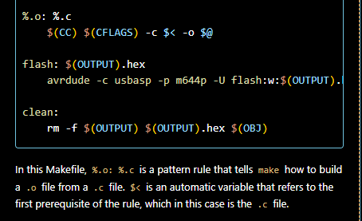
also in PuTTy, force on on both local echo and local line editing to make input text visible
https://stackoverflow.com/questions/4999280/how-to-send-characters-in-putty-serial-communication-only-when-pressing-enter
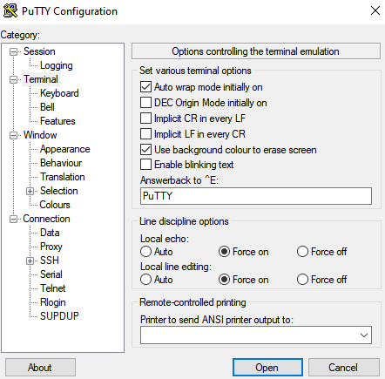

APP interfacing through UART via PuTTy to turn on, off and toggle LED works successfully.
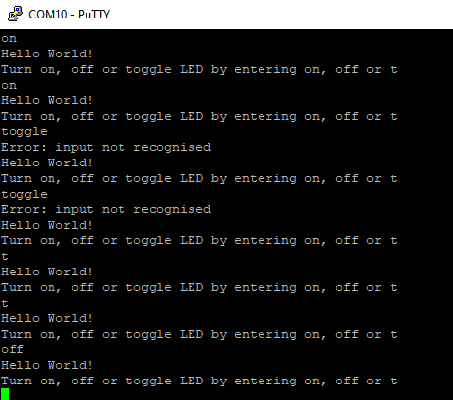
SUCCESS TEST V1
ALSO, can use .exe (GCC) to run unit test instead of avr-gcc. Can create mock function to simulate hardware.
Now I need to have it to always detect both either button press or UART input, and send APPDATA and related headers like PORT number, target HOSTNAME ip address etc

Ok a lot of stuff happened, tried simulating uplink and downlink from transport and seems working good enough, but damn interrupts for changing mode is the craziest
The bug is that there’s contention between isr uart rx and my uart reading function, and I should disable interrupt then re enable it or not there’ll be lots of weird bugs and byte skipping, and worse it give null character (ascii value 0) which is so annoying
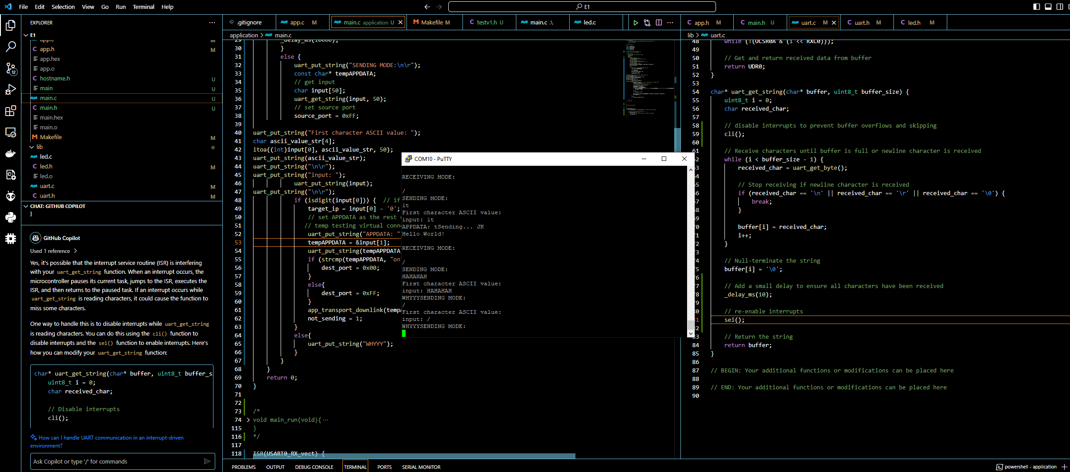
Solution ^
The said annoying skipping and null character bug
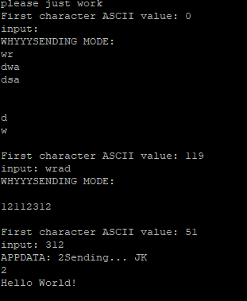
remember to disable isr (interrupt service routine) especially if its in same pin/functionality like my uart example wow…

took me like 2 hour for this one bug omg. Time to rest.

2/12/2023
Got the deets, uh I mean the components which are push buttons, some capacitors for hardware debouncing if I feel like it (probably not, using 100ms delay instead), some yellow and red leds.
Forgot to take some pull-up resistors (10k Ohms) but used some high resistance I have leftover in my toolbox.
Added button.c and button.h library to both application and AVR example repo.
Understanding differences between external interrupts and pin change interrupts, all pins have PC (pin change) interrupts service routine capabilities, but need to check pin by pin as it is called port by port.
Changed PA6 to PD2 back to PA6 after learning about above lol.
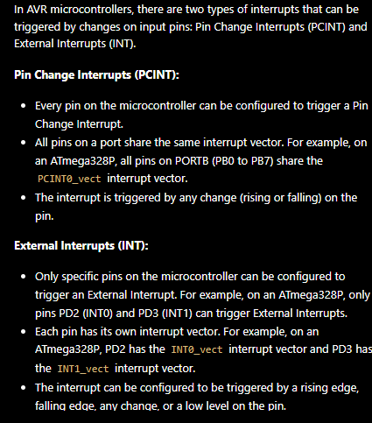
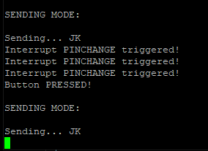heck yea work now, ig easier way now is to just do hardware debouncing lol

Nvm only one button pressed instance so no need!
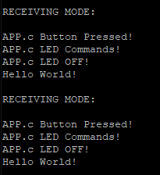huh interesting bug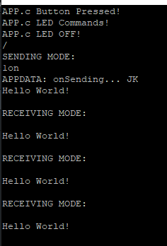
Ok it seems to be stuck on LED off on initial runtime and after each button push.
LETSGOOO TESTV2 WORKS, not optimal ofc but it works, maybe need to have hardware debounce and remove delay to make it feels faster, but IT WORKS
